Set the UUID from drush

Config export contain below UUID

**705ed7d8-5afd-4e0a-a590-1f9d145d7456**

Set the uuid before importing config

drush cset system.site uuid 705ed7d8-5afd-4e0a-a590-1f9d145d7456

If you don't have access to the original site/database, you can still sync from provided config files. The config will contain your site's UUID, so you need to set that first.

1. Find your config/sync directory: If it's moved, you can find where it was set in settings.php. Look for: $config_directories['sync'], which will list the path.
2. Go to that config path, and look for the file: system.site.yml In that file, look for uuid: 86b376c5-385e-4d13-bf00-e5e5443540e3 (you will have a different value, obviously). Copy that value.
3. In drush, set your site to the same site uuid that we just discovered: drush cset system.site uuid 86b376c5-385e-4d13-bf00-e5e5443540e3
4. Sync the config using drush drush cim -y
5. If you get errors, *read them*. I had:
   * a missing module (which I had to download and enable)
   * content from the shortcuts module, which I had to delete first, at:
   * admin > config > User Interfact > Shortcuts

Once I did that, I reran the cim, and everything worked like a charm!

I had installed a local D8 instance before trying to restore from the provided config

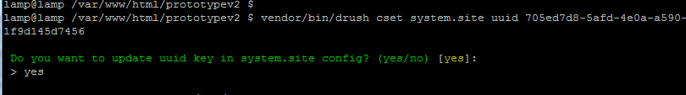

After import synchronise

DOC :

<https://jsfiddle.net/jaredwilli/xP48C/>

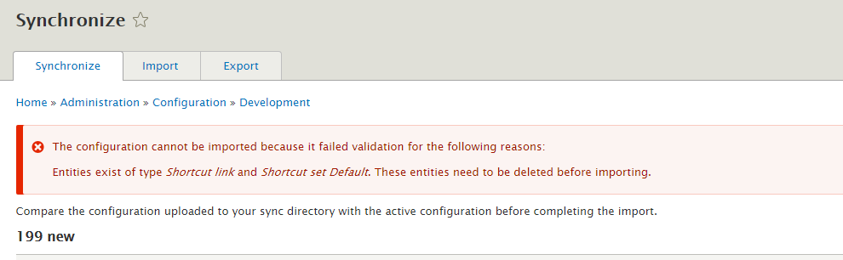

About the first error (Entities exist of type Shortcut link and Default. These entities need to be deleted before importing.):

I went to Home > Administration > Configuration > User interface > Shortcuts (admin/config/user-interface/shortcut), than in "List links" of "Default" I deleted every shortcut.